**Sensor Common Metadata Specification**

**Version 2.0**

**December 2024**

Data Quality

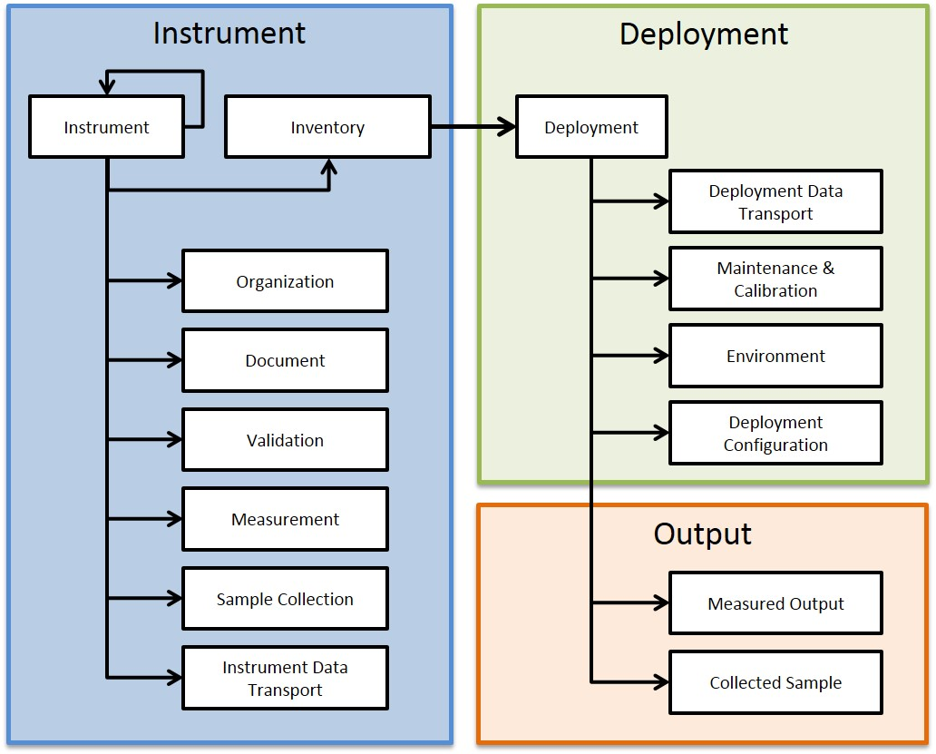

Library of Sensors Harmonized Store

# MIT License

**Copyright (c) 2016 University of Utah Biomedical Informatics Core, Center for Clinical and Translational Sciences.**

Permission is hereby granted, free of charge, to any person obtaining a copy of this software and associated documentation files (the "Software"), to deal in the Software without restriction, including without limitation the rights to use, copy, modify, merge, publish, distribute, sublicense, and/or sell copies of the Software, and to permit persons to whom the Software is furnished to do so, subject to the following conditions:

The above copyright notice and this permission notice shall be included in all copies or substantial portions of the Software.

THE SOFTWARE IS PROVIDED "AS IS", WITHOUT WARRANTY OF ANY KIND, EXPRESS OR IMPLIED, INCLUDING BUT NOT LIMITED TO THE WARRANTIES OF MERCHANTABILITY, FITNESS FOR A PARTICULAR PURPOSE AND NONINFRINGEMENT. IN NO EVENT SHALL THE AUTHORS OR COPYRIGHT HOLDERS BE LIABLE FOR ANY CLAIM, DAMAGES OR OTHER LIABILITY, WHETHER IN AN ACTION OF CONTRACT, TORT OR OTHERWISE, ARISING FROM, OUT OF OR IN CONNECTION WITH THE SOFTWARE OR THE USE OR OTHER DEALINGS IN THE SOFTWARE.

# Acknowledgement

These research efforts are supported by the following grants:

* National Institute of Environmental Health Sciences (NIEHS) of the National Institutes of Health under Award Number 1R24ES036134-01 (SMARTER)
* National Center for Advancing Translational Sciences (NCATS) of the National Institutes of Health under Award Number UL1TR001067 and UM1TR004409 [Utah CTSI] (EHIE)
* National Institute of Biomedical Imaging and Bioengineering (NIBIB) of the National Institutes of Health under Award Number U54EB021973 (PRISMS)

Research Computing provided by the Center for High Performance Computing (CHPC), University of Utah. CHPC resources is partially funded by NIH Research Instrumentation Award S10OD021644.

# Contact

For more information about:

* The SMARTER project visit: <https://www.smarterexposurehealth.org/>
* The Exposure Health Informatics Ecosystem: <http://ceehi.ccts.utah.edu/background-prisms-informatics/>

Details about the Center of Excellence for Exposure Health Informatics are available at: <http://ceehi.ccts.utah.edu/>

You can contact us at: [smarterexposurehealth@utah.edu](mailto:smarterexposurehealth@utah.edu)

**Table of Contents**

MIT License 2

Acknowledgement 3

List of Figures 6

List of Tables 7

1. Introduction 8

1.1 Project Background 8

1.2 Purpose of the Common Metadata Specification 9

1.3 Development Process 10

1.4 Glossary of Terms 11

1.5 Design Overview 12

1.6 Implementation 13

2. Instrument 17

2.1. Instrument model 17

2.2. Instrument Inventory 20

2.3. Measurement 21

2.4. Validation 23

2.5. Instrument Data Transport 25

2.6. Organization 27

2.7. Document 28

2.8. Sample Collection 29

3. Deployment 31

3.1. Deployment 31

3.2. Maintenance and Calibration 33

3.3. Environment 37

3.4. Deployment data transport 41

4. Output 42

4.1 Measured Output 42

4.1 Collected Sample 43

# List of Figures

Figure 1: Diverse use-cases supported by the specifications. 9

Figure 2: Four step specifications development process 9

Figure 3: Sample data used for developing the specifications. 10

Figure 4: Domains and entities of the SCMS. 12

Figure 5: Entity relationship diagram of SCMS. 14

Figure 6: Entities and attributes of SCMS. 15

# List of Tables

Table 1: Research questions supported by these specifications. 8

Table 2: Glossary of Terms used in the specifications. 10

Table 3: Instrument model entity details. 16

Table 4: Instrument inventory entity details. 19

Table 5: Measurement entity details. 20

Table 6: Validation entity details. 22

Table 7: Instrument data transport entity details. 24

Table 8: Organization entity details. 26

Table 9: Document entity details. 27

Table 10: Sample Collection entity details. 28

Table 11: Deployment entity details. 30

Table 12: Maintenance and Calibration entity details. 32

Table 13: Environment entity details. 36

Table 14: Measured Output entity details. 41

# Introduction

Sensors, especially personal and mobile sensors provide methods for measuring environmental exposures of individuals and populations. But sensors use different methods and technologies for measuring different environmental species and output their measurements in different formats and specifications. In addition, sensors have differences in their performances and uncertainties associated with their measurements. It is therefore necessary to describe sensors in a generalized and sharable manner to support their proper use.

The Sensor Common Metadata Specification (SCMS) is designed to support the conduct of research utilizing personal and environmental sensors. The scope of the specification ranges from nano-sensors to satellites. Sensor measurements may include physical, chemical, and biological species. In addition, sensors including that instantaneously (or with a transient storage with implicit processing or averaging time) measure these species or those that collect physical samples for later analysis. Sensors may be deployed in various environments, including personal (i.e. implanted & wearable), immediate (i.e. indoor), and general environment (i.e. external environmental protection agency monitors). Sensors could also be mobile or stationary.

This business specification document may serve as a guide for sensor data modeling within any data management technology as required for your specific implementation. For example, you can use these specifications to develop relational, graphical or document stores of your sensor data. In similar line, we plan to develop a separate data modeling document for our data platform based on the specifications document.

A *sensor* measures one particular species. In this document *device* is used interchangeably with *instrument*. A device or instrument may be comprised of one or more measuring sensors, and device (or instrument) may contain other devices in a hierarchical manner. This terminology attempts to reduce the confusion that a sensor may contain other sensors.

## 1.1 Project Background

Understanding the effects of the modern environment on pediatric asthma requires generation of a complete picture of environmental exposures, clinical, biological and socio-behavioral factors. Such an exposome requires integration of data from wearable and stationary sensors, environmental monitors, physiology, medication use, clinical, socio-behavioral and other data with spatiotemporal coordinates.

This work builds on the work performed as a part of the he Pediatric Research using Integrated Sensor Monitoring Systems (PRISMS) program (<https://www.nibib.nih.gov/research-funding/prisms>) for performing exposomic studies of pediatric asthma and other chronic diseases. Sensors and Metadata for Analytics and Research in Exposure Health (SMARTER) project, a University of Utah project initiated in 2024, is developing community-driven, shared, generalizable metadata and data management tools that support reproducible exposure health research. These metadata artifacts will be leveraged within and without the Exposure Health Informatics Ecosystem to perform exposure health and exposomic studies.

These specifications will be used in the development of informatics platform for data exposomic data collection, harmonization, semantic integration and provisioning of the data for different research study analyses and visualizations. These specifications will be used at the Utah Informatics platform to develop a logical data model to store and harmonize metadata from sensors and load it into a metadata repository to support metadata driven semantically consistent integration of all data.

## 1.2 Purpose of the Common Metadata Specification

The purpose of the SCMS is to:

1. Establish a library of instruments: Investigators can use this library to select appropriate instruments for different studies and acquire information necessary to contact the organizations owning or manufacturing these with instruments.
2. Describe and document deployments of sensors: Store a sensor’s environmental and deployment attributes that are useful when using the measurements for analysis.
3. Assess quality of data collected by different instruments within its deployment environments: Use descriptive metadata to compare sensors and check if measurements are as expected.
4. Support harmonization and integration of data collected from various sensors
5. Provide a guide for structuring and storing sensor output data

The scope of the specification is to support a diverse set of exposomic research questions and studies (Table *1*) including observational, epidemiological and prospective studies (Figure *1*).

Table 1: Research questions supported by these specifications.

|  |
| --- |
| 1. *Mobile Instrument Models that can measure PM2.5.* 2. *Mobile Instrument Models that have been deployed to measure PM2.5.* 3. *Serial Number of all Instruments deployed supporting REST Data Transport Protocols and capturing output of PM2.5 (Or PM10, or Ozone).* 4. *Instrument Models that were manufactured by the AirMetrics.* 5. *Deployed Instruments owned University of Utah and currently measuring Ozone.* 6. *Organizations the collected personal exposures of PM2.5 in indoor and outdoor environments.* 7. *Calibration procedures used for MiniVol when deployed in an area with tall buildings.* 8. *Reference detection limit of MiniVol to assess quality of data quality in a study.* 9. *Number of sensors deployed by University of Utah in Salt Lake County that are less than 100 meters of I-15 in April 2016, and give the geolocation of each sensor and species measured by each sensor.* |

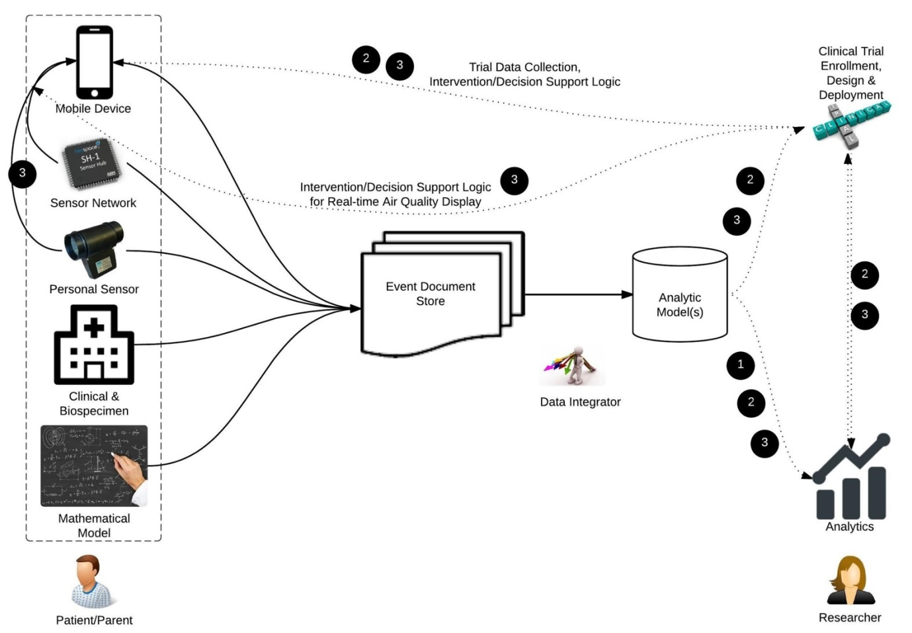

Figure 1: Diverse use-cases supported by the specifications.

## 1.3 Development Process

We are following a four step process in developing the Sensor Common Metadata Specification (SCMC).

Figure 2: Four step specifications development process

1. Literature Review: We performed a literature review using PubMed with the search criterion “Pediatric Asthma Sensor Studies.” This returned 231 journal articles from August 1985 - December 2015, of which 40 full texts were read. Sensor types found in this literature corpus included regional stationary sensors (e.g. EPA), personal sensors (mobile), and indoor and outdoor sensors. A list of metadata elements were manually extracted from this literature corpus, and the first conceptual model was established.
2. Preliminary mapping with sample data: To further establish the model, we did a preliminary mapping of sample data with the conceptual model. Sample data included data from the Environmental Protection Agency (EPA), Utah Department of Air Quality (UDAQ), MesoWest (<http://synopticlabs.org/>), West Valley Study (UDAQ), Asthma Triggers (Dr. Rima Habre), Wood Burning (Dr. Kerry Kelly), Purple Air (Mr. Adrian Dybwad, <http://www.purpleair.org/>), Modeled Air Quality Data (1999 to 2007, 6 km grid, Dr. Jeffrey Yanosky), Measured Air Quality Data with Altitude (Dr. Geoff Silcox), and Hierarchical Bayesian Modeled Air Quality Data (EPA). Existing fields found in the data, but not present in the model, were added to the model.

Figure 3: Sample data used for developing the specifications.

1. Utah Expert Review: We then reviewed the model with air quality experts in Utah Experts included: Dr. Kerry E. Kelly, Assistant Professor, Chemical Engineering, University of Utah; Dr. John D. Horel, Professor, Atmospheric Sciences, University of Utah; Dr. Scott C. Collingwood, Research Assistant Professor, Pediatrics, University of Utah; Mr. Adrian Dybwad, Purple Air; and Dr. Neal Patwari, Associate Professor, Electrical Engineering, University of Utah. We modified the model further based on their inputs
2. Community review of version 1.0: We share the SCMS with the PRISMS community and with help of assisted surveys review the model.

## 1.4 Glossary of Terms

Table 2: Glossary of Terms used in the specifications.

|  |  |
| --- | --- |
| **Term** | **Description** |
| Calibration | Operation that, under specified conditions, in a first step, establishes a relation between the quantity values with measurement uncertainties provided by measurement standards and corresponding indications with associated measurement uncertainties (of the calibrated instrument or secondary standard) and, in a second step, uses this information to establish a relation for obtaining a measurement result from an indication. *(*[*JCGM 200:2008 International vocabulary of metrology*](http://www.bipm.org/utils/common/documents/jcgm/JCGM_200_2008.pdf) *— Basic and general concepts and associated terms (VIM)).* Broadly this also includes QA/QC procedures built into the deployment and study design. For example, blank samples and duplicate/replicate samples vs routine samples within the study. Blanks are used to estimate the limit of detection and correct for it post-hoc and routines are used to determine precision or repeatability. |
| Concept Identifier (ID) | An Identifier that uniquely identifies a Concept. |
| Concept | Represents a set or class of entities or things within a domain. Also called concept name. |
| Namespace | An abstract container to hold a logical grouping of unique concepts or identifiers. |
| Data | In this specifications data refers to all measurement values. |
| Deployment | The event that the physical instrument is utilized and brought to effective action. |
| Device | A composite set of one or more sensors each of which captures a specific measurement. Used interchangeably with instrument. |
| Graph Database | A database that uses graph structures of nodes, edges and properties to represent and store data. |
| Instrument | A composite set of one or more sensors each of which captures a specific measurement. Used interchangeably with device and monitor. |
| Metadata | Information that provides description of measured data from sensors, the deployment of sensors, and the sensors itself. |
| Metadata Repository | A store for metadata that can be leveraged in computational platforms. |
| Relational Database | A digital database whose organization is based on the relational model of data. |
| Sensor | A thing that is capable of making a specific observation or measurements of the real world and contains one or more instruments. |
| Species | An entity that is subject to measurement. |
| Validation | The process to test and evaluate whether an instrument has the capacity to measure what it is supposed to measure. |

## 1.5 Design Overview

The SCMS consists of three domains (Figure *4*).

1. Instrument: The instrument domain contains data elements that describe a physical inventory of manufacturer models, along with its documentation, data transport, validation tests, measurement features, and owning and manufacturing organizations. It can be used to maintain a library of instruments using which researchers can make informed selections of instruments for different research purposes.
2. Deployment: The deployment domain contains data elements that describe how a physical instrument is deployed in real world and includes characteristics such as the instruments deployment environment, setting, data transport, and calibration.
3. Output: The output domain contains data elements that describe the measurement of the sensors or the physically collected samples of different species.



Figure 4: Domains and entities of the SCMS.

## 1.6 Implementation

The three domains of the Sensor Common Model Specification (SCMS) may be implemented with various database technologies (e.g. relational, graph, or document databases. Here are some examples of how you may implement the 3 domains.

1. **Instrument**: This is a functional description of each sensor including its ownership and manufacturer specifications. These metadata can be stored as a library for supporting investigator selection of appropriate sensors and deploying for different studies.

These metadata may be best implemented as a relational or a graph metadata repository. Document databases are not recommended here since this Library portion of the model is highly interconnected. If you plan to directly store large amounts of binary objects such as PDF documents as a part of the metadata, a relational database would be better suited since graph databases have very limited support for binary large objects. On the other hand, if you plan to only store file paths to external files then a graph database may be more suitable as graphs have better support for hierarchical structures such as instruments containing a hierarchy of sensors. Graph databases also have better support for web-linked data. In other words, graphs provide better support for ternary or more degrees of relationship types, along with many-to-many cardinality as in the case of the Instrument's self-referencing relationships and the ternary degree relation between the Instrument, Organization, and Inventory entities. We implemented this in a graph database.

1. **Deployment**: This is the metadata regarding how each physical instrument or sensor is deployed. Deployment provides information on how the device was configured and setup in particular environments. This metadata informs investigators on how Output was captured, allowing investigators to make appropriate decisions on choosing the right output data for specific study analysis.

The deployment model is fairly simple with one-to-many relationships surrounding the Deployment entity type. Therefore, a relational or graph database may be equally well suited.

1. **Output**: The actual output received from each deployed instrument. A document store database may be better suited for this purpose. Sensor output may be generated with a high frequency and generally sensors output a type of file such as JSON or XML or text file, which fits well with the nature of a document data storage. The high throughput of data may also require the use of Big Data technologies such as a distributed file system and a framework for parallel data processing. Document databases are generally well suited and designed for Big Data technologies.

For example, imagine 100 sensors collecting data every minute, over a period of one year. That would mean 100 x 1440 x 365 = 52,560,000 records. Although this may sound reasonable for a relational DB, if we scale this up to 1000 sensors collecting data every 10 seconds, for ten years would mean; this would mean 1000 x (1440 x 6) x 3650 = 31,536,000,000 records. This would become much more difficult to transform, process and store in a single large relational table.

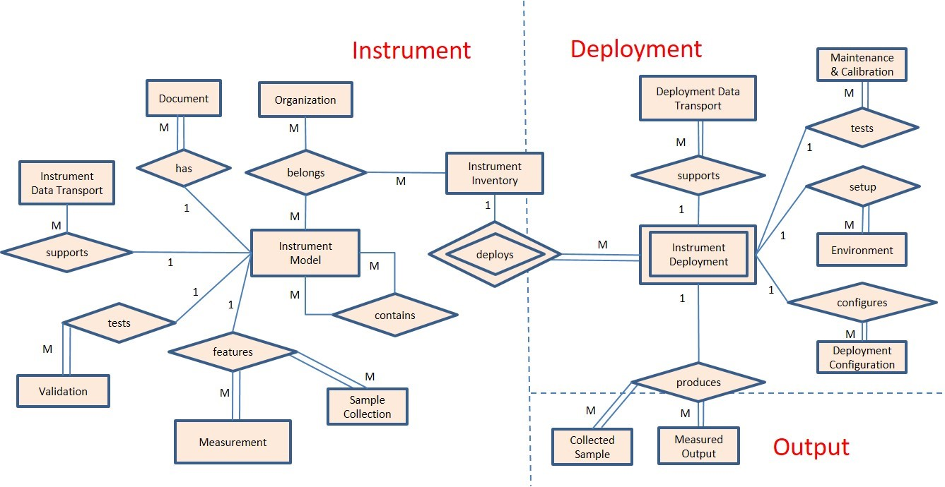

Figure 5: Entity relationship diagram of SCMS.

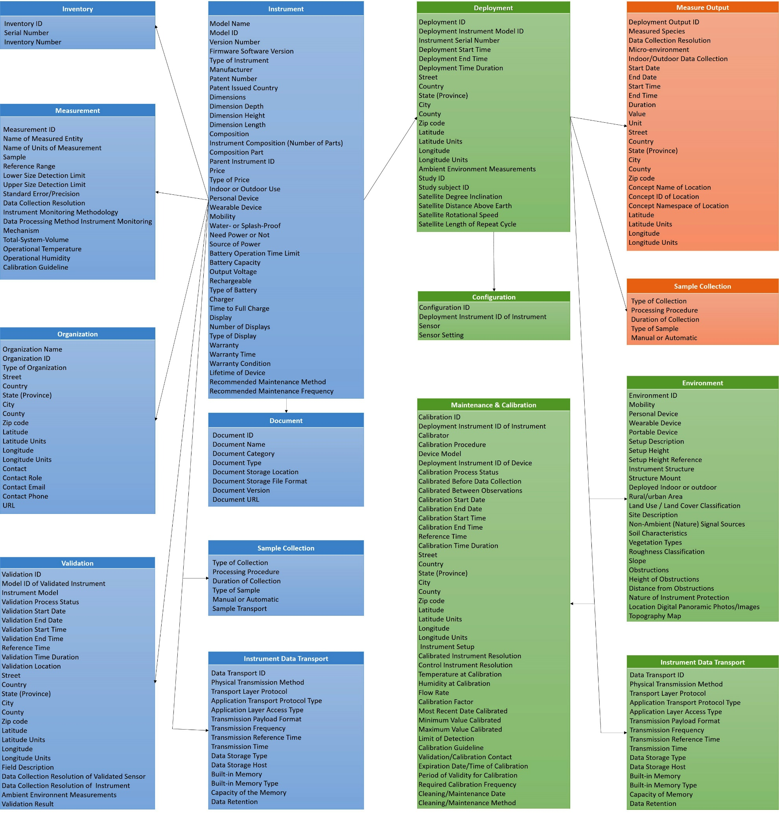

Figure 6: Entities and attributes of SCMS.

# Instrument

## Instrument model

The Instrument model data element is a list of metadata elements used to describe general information about the instrument, such as the model, capacity, version, content, power, display, manufacturer, price and species it measures.

Table 3: Instrument model entity details.

|  |  |  |  |  |
| --- | --- | --- | --- | --- |
| **Data Element** | **Required** | **Description** | **Data Type** | **Example Value** |
| Model Name | Y | The term by which the instrument is known. This could be a trade name or an alias. | String | AirU, MiniVol™ TAS, FooBot, Dylos 1700, personal UFP (PUFP) sensor |
| Model ID | Y | The unique identifier used to differentiate each model of an instrument made by certain manufacturer. | String (Numerical) | DC 1700, DC 1100 |
| Version Number | N | The current version of the instrument model. It differentiates instruments within the same model.  The usually refers to a version of the hardware. | String (Numerical) | 1,2,3, alpha, beta |
| Firmware Software Version | N | Current firmware or software version of the model. | String | 1,2,3 |
| Type of Instrument | N | The category of instrument based on the species measured by the instrument. | Category | Gas sensor, particle sensor, volatiles or semi-volatiles |
| Manufacturer | N | The person, group, or organization that develops or produces the instrument. | String | University of Utah, Airmetrics |
| Patent Number | N | The serial number of the patent, if the instrument is patented. | String | Patent # US 844965 |
| Patent Issued Country | N | The country issuing the patent. | Category | US |
| Dimensions | N | The size of the instrument in physical space. The dimension could have attributes of depth, height, and length. Each dimension includes a value and unit. (Use this if the dimensions aren’t available discretely, else use the below fields.) | Value and Unit | 10 x 10 x 5 cm; 10 in * 20 in * 15 in; depth: 10 cm, height: 10 cm, width: 10 cm |
| Dimension Depth | N | The depth or thickness of the instrument. | Value and Unit | 10 cm |
| Dimension Height | N | The vertical height of the instrument. | Value and Unit | 20 mm |
| Dimension Length | N | The horizontal length of the instrument. | Value and Unit | 3 nm |
| Composition | N | The description of the composition of combining parts or elements making up of the instrument. | String | Comprised of an evaporation–condensation-tube, a miniature diaphragm air pump, an optical detection module, a flow regulator, water tank, GPS, and battery pack in a plastic shell body. The instrument includes 3 parts, and they are PM2.5 sensor, GPS module, and a backpack |
| Parent Instrument ID | N | Foreign Key. The Instrument Model ID representing the parent instrument containing this instrument. | String (Numerical) | 12345.6 |
| Price | N | The cost of the instrument. This could be a potential price or price range of the instrument, such as the manufacturer recommended price, actual price, or price range to purchase the instrument. | Value and Unit | $30 |
| Type of Price | N | Whether the price/price range is the potential price or actual price to purchase the instrument. | Category | Manufacturer recommended price |
| Indoor or Outdoor Use | N | Whether the instrument is intended to be used inside a building or structure that is protected from the natural environment. Or, if the instrument can be used outdoors and can tolerate exposure to the natural environment. | Category | Indoor, outdoor, indoor/outdoor, indoor and outdoor |
| Personal Device | N | Whether or not the instrument is intended to be used to and track information for individuals. | Yes, No | Yes, No |
| Wearable Device | N | Whether or not the instrument can be worn by individuals on their body or carried, and track information. | Yes, No | Yes, No |
| Mobility | N | Whether the instrument can be moved around for measuring the species. | Category | Mobile, fixed |
| Water- or Splash-Proof | N | Whether or not the instrument can tolerate exposure to water. | Yes, No | Yes, No |
| Need Power or Not | N | Whether or not the instrument needs a source of power for its normal function. If power is needed, the type of power should be listed. See "Source of Power." | Yes, No | Yes, No |
| Source of Power | N | The type of power that supports the instrument for its normal function/s. | Category | Battery, AC, solar, wind |
| Battery Operation Time Limit | N | The duration of battery life, if the "source of power" is battery. | Value and Unit | 12 hours |
| Battery Capacity | N | The amount of electric charge the battery can deliver at the rated voltage. | Value and Unit | 2200mAh |
| Output Voltage | N | The voltage released by the battery. | Value and Unit | 14.8V |
| Rechargeable | N | Whether or not the battery's electric charge can be restored by connecting the battery to a recharging device. | Yes, No | No |
| Type of Battery | N | The category of battery, based on the chemical used in the battery's electrochemical cells. | String | Lithium Ion batteries, Nickel–cadmium battery |
| Charger | N | If the battery is rechargeable, this element is used to describe the charger. | String | 1.2 amp external battery charger |
| Time to Full Charge | N | The time taken to recharge the battery. | Value and Unit | Full recharge in less than 6 hours |
| Display | N | Whether or not the instrument is capable of displaying information. If yes, more information can be recorded in the following data element, such as how many monitors, and what type of monitors does it have. | Yes, No | Yes |
| Number of Displays | N | The number of displays with the instrument. | String (Numerical) | 2 |
| Type of Display | N | The category of the monitor used to display information. | Category | LCD screen, LED monitor |
| Warranty | N | Whether or not the instrument comes with a warranty. If Yes, more information can be provided, such as the warranty time and warranty condition. | Yes, No | Yes |
| Warranty Time | N | The length of time covered by the instrument's warranty. | Value and Unit | 1 year |
| Warranty Condition | N | The facts or conditions under which the warranty is valid. | String | The period of warranty shall start from the date of delivery of the product to the customer and shall cover a period of 2 years |
| Lifetime of Device | N | The duration of time during which the instrument is expected to function properly according to the manufacturer. | String | Re-usable; If a problem must replace (not repairable) |
| Recommended Maintenance Method | N | The method suggested for maintaining the instrument. | String | Clean with compressed air |
| Recommended Maintenance Frequency | N | The frequency at which the maintenance should be repeated | String | At least once a month |

* + 1. Conventions
* Each type of instrument with a certain model made by a certain manufacturer will have an instrument model ID.
* The instrument is uniquely identified by its instrument model and the version of the hardware/software. The Instrument Modeled ID is the unique identifier to differential certain type of instrument with certain model and specific hardware/software version.

## Instrument Inventory

The Instrument Inventory is used to register the physical instrument of a specific model with certain version in a library of sensors.

Table 4: Instrument inventory entity details.

|  |  |  |  |  |
| --- | --- | --- | --- | --- |
| **Data Element** | **Required** | **Description** | **Data Type** | **Example Value** |
| Inventory ID | Y | This is a foreign key to Instrument Model | Number | 123 |
| Serial Number | Y | Serial number of physical Instrument | String | A1B234567 |
| Inventory Number | N | Internal inventory number used to uniquely identify each instrument. | String | A1B234567 |

## Measurement

The measurement data element is a list of metadata elements used to describe the characteristics of a species that the instrument measures.

Table 5: Measurement entity details.

|  |  |  |  |  |
| --- | --- | --- | --- | --- |
| **Data Element** | **Required** | **Description** | **Data Type** | **Example Values** |
| Measurement ID | Y | An identifier generated by the system that identifies each type of measurement. | String (Numerical) | 12345 |
| Name of Measured Entity | N | A name representing the measured entity which is assigned by the system or taken from a reference terminology or ontology. | String | Fine particles, motion, temperature |
| Units of Measurement | N | A name representing the units of measurement which is assigned by the system or taken from a reference terminology or ontology. | String | µg/m3 |
| Sample | N | A category referring to the nature of the sample analyzed to measure an entity. | Category | Air, Exhaled breath |
| Reference Range | N | The reference range used by the instrument for the limit of detection. This could include the upper value and the lower value. | Range (Value and Unit) | 0 µg/m3 to 1.6 µg/m3 |
| Lower Size Detection Limit | N | A manufacturer reference limit value distinguishing the lower size detection limit of the instrument. The format could be of a value and unit. | Value and Unit | 10 um |
| Upper Size Detection Limit | N | A manufacturer reference limit value distinguishing the upper size detection limit of the instrument. The format could consists of a value and unit. | Value and Unit | 100 um |
| Standard Error/Precision | N | An indication used to represent the precision of instrument. | Value and Unit | ±16% |
| Data Collection Resolution | N | Time granularity range used for data collection. | Value and Unit | 1 second |
| Instrument Monitoring Methodology | N | The description of the method utilized by the instrument for monitoring. | String | Resistor for humidity sensor and a thermostat for temperature; particle counter based on light-scattering technology |
| Data Processing Method Instrument Monitoring Mechanism | N | The description of the mechanism by which the signal and data are generated and processed | String | The two central processing units on a board convert analog laser particle scattering signature to digital counting data along with the global positioning system (GPS). |
| Total-System-Volume | N | This value represents the capacity of the instrument to collect a sample by volume. | Value and Unit | 1500 cm3 |
| Operational Temperature | N | The reference range of temperature used for the instrument under normal working conditions. This could be a range of temperature with upper and lower values. | Value and Unit | 50 F to 80 F |
| Operational Humidity | N | The reference range of humidity used for the instrument under normal working condition. This could be a range of humidity with upper and lower values. | Value and Unit | 80% to 90% |
| Calibration Guideline | N | A reference to whether or not a calibration guideline exists for the instrument sensor. If yes, the text, document, or links of the manufacturer's recommended calibration should be listed. | Boolean | Yes or no, if yes, the text, document, or links of the manufacturer's recommended calibration should be listed. |

* + 1. Conventions
* Each measurement will have a measurement ID.

## Validation

The validation is the process to test and evaluate the instrument’s capability of measuring what it supposed to measure. The Validation data element is a list of metadata elements used to describe the process, settings and results of the validation process.

Table 6: Validation entity details.

|  |  |  |  |  |
| --- | --- | --- | --- | --- |
| **Data Element** | **Required** | **Description** | **Data Type** | **Example Value** |
| Validation ID | Y | A unique identifier used to differentiate each validation event. | String (Numerical) | 123456 |
| Model ID of Validated Instrument | Y | The identifier that identifies the instrument validation. This ID is a foreign key linking the Validation entity to the Instrument Model entity which documents the information about the validated instrument. | String (Numerical) | 123 |
| Instrument Model | Y | The device used as a reference to validate the instrument. The data generated from the tested instrument is compared with the data of control device. If the controlled device is registered as an instrument model entity, the Versioned Instrument ID of the controlled device should be provided. Control device used for validation. This could be an "instrument" entity. Refer to "instrument administration data" | String | PMS 1003 |
| Validation Process Status | N | The current state or condition status of the validation process. | Category | In process, done |
| Validation Start Date | N | The point in time as month, day, year, where validation begins. | Date | 05May2016 |
| Validation End Date | N | The point in time as month, day, year where validation terminates. | Date | 05May2016 |
| Validation Start Time | N | The point in time as hour, minute, seconds where validation begins. | Time | 01:22:16 |
| Validation End Time | N | The point in time as hour, minute, seconds where validation terminates. | Time | 02:22:16 |
| Reference Time | N | Time zone of the validation. | Category | Mountain Standard |
| Validation Time Duration | N | The amount of time it took to validate the instrument. | Value and Unit | 3 months |
| Validation Location | N | The name of the location where the validation took place. | String | In the lab |
| Street | N | The street where the instrument was validated. | String | 545 South 700 East |
| Country | N | The country where the instrument was validated. | String | USA |
| State (Province) | N | The state (province) where the instrument was validated. | String | UT |
| City | N | The city where the instrument was validated. | String | Salt Lake City |
| County | N | The county where the instrument was validated. | String | Salt Lake |
| Zip code | N | The zip code where the instrument was validated. | String (Numerical) | 84102 |
| Latitude | N | The latitude in which the organization resides. | String (Numerical) | 40.76 |
| Latitude Units | N | The direction in which the latitude is running. | String | Degrees North |
| Longitude | N | The longitude in which the organization resides. | String (Numerical) | -111.863, 111.863 |
| Longitude Units | N | The direction in which the longitude is running. | String | Degrees West, West |
| Field Description | N | The description of the site where the instrument is set up. | String | In an open field near the I-15; In an open field surrounded by the trees |
| Data Collection Resolution of Validated Sensor | N | Time step for data collection of the tested instrument. | Value and Unit | 1s, 1min |
| Data Collection Resolution of Instrument | N | Time step for data collection of the instrument. | Value and Unit | 1s, 1min |
| Ambient Environment Measurements at Validation | N | Ambient temperature, humidity, altitude, pressure during validation. These measurements will link using identifiers in the Output entity. | Value and Unit | 75F, 30C, 70% |
| Humidity at Validation | N | Ambient humidity during calibration. | Value and Unit |  |
| Validation Result | Y | The performance of the tested instrument when compared with the instrument. | String | The correlation of the PM2.5 from the two sensor is 0.9; passed the validation |

* + 1. Conventions
* Each Validation event should have a unique identifier, the Validation ID.
* The instrument that is used for validation is called “Validation Instrument”, whereas the instrument that is used as a reference device for validation is called “Control Instrument”.
* The Versioned Model ID of the Validation Instrument is used as a foreign key to link the Validation event with the information of the instrument that is evaluated.
* The Versioned Model ID of the Control Instrument is used as a foreign key to link the Validation event with the information of the instrument that is used as a reference device.

## Instrument Data Transport

The Instrument Data Transport data element is a list of metadata elements that describe the capacity of the data community between the instrument and the data storage center.

Table 7: Instrument data transport entity details.

|  |  |  |  |  |
| --- | --- | --- | --- | --- |
| **Data Element** | **Required** | **Description** | **Data Type** | **Example Value** |
| Data Transport ID | Y | The unique identifier used to differentiate data transport from others. | String (Numerical) | 123 |
| Physical Transmission Method | N | Means of transmission of data from field to initial central collection point. | category | Point to Point RF, LAN, satellite downlink, blue tooth, Wi-Fi, cellular network, landline telephony, upload to server, other |
| Transport Layer Protocol | N | Type of transport layer implemented by the physical transmission method. | category | TCP/IP, UDP,PROPRIETARY |
| Application Transport Protocol Type | N | Type of protocol used for connectivity implementation of data transmission. | category | HTTP,HTTPS,SMTP,JMS,SSH,PROPRIETARY |
| Application Layer Access Type | N | Access method to the data stored from the sensor. | category | API-REST,API-SOAP,JDBC, SQL |
| Transmission Payload Format | N | Type of message used for data transmission. | category | csv, xml, json, binary |
| Transmission Frequency | N | Frequency of data transmission. | string | real time, twice a day, every 30 minutes |
| Transmission Reference Time | N | Reference time used. | category | Greenwich Mean Time (GMT) |
| Transmission Time | N | Time duration of the data transmission. | value and unit | 12 hours |
| Data Storage Type | N | Category of physical data storage mechanism. | category | cloud storage, data warehouse, direct broadcast station, localhost |
| Data Storage Host | N | Description of the hostname and location of the data storage. | string | data.proxyhost.somewhere.com, 127.0.0.1 |
| Built-in Memory | N | Does the instrument have built in memory or not. | Yes, No | Yes |
| Built-in Memory Type | N | The kind of memory the instrument uses for the built-in memory. | category | volatile, non-volatile |
| Capacity of the Memory | N | The storage space of the built-in memory. | Value and unit | 12MB |
| Data Retention | N | The action to be taken when out of memory. | category/String | overwriting oldest data |

* + 1. Conventions
* Each Instrument Data Transport will have a unique Data Transport ID.

## Organization

The Organization data element is a list of metadata elements used to describe an organization (i.e., owner, manufacturer, etc.) tied to the instrument.

Table 8: Organization entity details.

|  |  |  |  |  |
| --- | --- | --- | --- | --- |
| **Data Element** | **Required** | **Description** | **Data Type** | **Example Values** |
| Organization Name | Y | A name representing the organization. | String | University of Utah, EPA |
| Organization ID | Y | An identifier generated by the system that identifies a unique organization in our database. | String (Numerical) | 12345 |
| Type of Organization | N | A representative category for which the organization belongs. | Category | Manufacturer, owner, research institute, government |
| Street | N | The street in which the organization resides. | String | 545 South 700 East |
| Country | N | The country in which the organization resides. | String | USA |
| State (Province) | N | The state (province) in which the organization resides. | String | UT |
| City | N | The city in which the organization resides. | String | Salt Lake City |
| County | N | The county in which the organization resides. | String | Salt Lake |
| Zip code | N | The zip code in which the organization resides. | String (Numerical) | 84102 |
| Latitude | N | The latitude in which the organization resides. | String (Numerical) | 40.76 |
| Latitude Units | N | The direction in which the latitude is running. | String | Degrees North |
| Longitude | N | The longitude in which the organization resides. | String (Numerical) | -111.863, 111.863 |
| Longitude Units | N | The direction in which the longitude is running. | String | Degrees West, West |
| Contact | N | A name for the contact within the organization. | String | John Doe |
| Contact Role | N | The role/s the contact possesses within the organization. | Category | Manager, staff |
| Contact Email | N | An email address to contact the organization's contact. | String | JohnDoe@gmail.com |
| Contact Phone | N | A phone number to contact the organization's contact. | String (Numerical) | (800) 123-4567 |
| URL | N | An address to a resource on the Internet that contains information regarding the organization. | String | [www.organization.com](http://www.organization.com/) |

* + 1. Conventions
* Each organization will have an organization ID.

## Document

The Document data element is a list of metadata elements used to describe any documentation supporting instrument models.

Table 9: Document entity details.

|  |  |  |  |  |
| --- | --- | --- | --- | --- |
| **Data Element** | **Required** | **Description** | **Data Type** | **Example Value** |
| Document ID | Y | The unique identifier that is used to differential the document with the other documents. | String (Numerical) | doc.1 |
| Document Name | N | The name of the document. | String | User manual for MiniVol |
| Document Category | N | The category of the document. | Category | User manual, calibration guideline, topography map, location photo |
| Document Type | N | The type of the document. | Category | Hardcopy, online, electronic copy |
| Document Storage Location | N | The location where the document is stored. This could be a physical place, on the hardware, or online. If online, the URL might be provided. | String | In the shipping box, in the database, in the hardware |
| Document Storage File Format | N | If electronic, the document file format. | Category | pdf, MS world, HTML, ASCII |
| Document Version | N | The version of the document. | String (Numerical) | 1.0.0;1.0.1, alpha, beta |
| Document URL | N | URL of the document, if online. | String | <http://www.airmetrics.com/products/minivol/> |

* + 1. Conventions
* Each Document will have a unique Document ID.

## Sample Collection

The Sample data element is a list of metadata elements that describe the characteristics of samples collected by the instrument and the procedure used for sample collection.

Table 10: Sample Collection entity details.

|  |  |  |  |  |
| --- | --- | --- | --- | --- |
| **Data Element** | **Required** | **Description** | **Data Type** | **Example Values** |
| Type of Collection | N | How the sensor collects data | Category | Filter, bag, cartridge |
| Processing Procedure | N | How to find the value of the measurement | Text | Weight, Send to Lab, Integrated vs continuous, gravimetric vs other |
| Duration of Collection | N | How long the sensor is open to collect data | String (Numerical) | 3 days |
| Type of Sample | N | The entity the sensor captures. | Category | Air |
| Manual or Automatic | N | Does the sensor require a human to measure the value output? | Category | Manual, Automatic |
| Sample Transport | N | Instructions on how sample needs to be transported to a laboratory for testing. E.g. Ogawa passive badges, or any of the biological samples. | Text | On dry ice, Sealed from external air |

# Deployment

The Deployment is the event that the physical instrument is utilized and brought to effective action.

## Deployment

The Deployment data element is a list of metadata that is used to describe the details of how, when, where and for what the instrument is deployed into action. For instruments with different types, specific metadata element might be listed to document the deployment. For example, specific data elements, such as Satellite Degree Inclination, is from the deployment of satellite.

Table 11: Deployment entity details.

|  |  |  |  |  |
| --- | --- | --- | --- | --- |
| **Data Element** | **Required** | **Description** | **Data type** | **Example Values** |
| Deployment ID | Y | A unique identifier used to distinguish the deployment. | String (Numerical) | DEP.1 |
| Deployment Instrument Model ID | Y | An identifier generated by the system that identifies very unique deployed instrument. | String | 12345 |
| Instrument Serial Number | Y | A number provided by a manufacturer showing the position of an instrument in a series for the purposes of identification. | String | 12345 |
| Deployment Start Time | N | The time at which the instrument was deployed. Note this could be different from the time when the instrument starts measuring. | Date-Time |  |
| Deployment End Time | N | The point in time at which the instrument deployment terminated. Note this could be different from the time when the instrument ends measuring. | Date-Time |  |
| Deployment Time Duration | N | The duration of time an instrument has been deployed, if Deployment Start and End Times are available. | Time | 6 weeks, 21 months |
| Street | N | The street in which the instrument is deployed. | String | 545 South 700 East |
| Country | N | The country in which the instrument is deployed. | String | USA |
| State (Province) | N | The state (province) in which the instrument is deployed. | String | UT |
| City | N | The city in which the instrument is deployed. | String | Salt Lake City |
| County | N | The county in which the instrument is deployed. | String | Salt Lake |
| Zip code | N | The zip code in which the instrument is deployed. | String (Numerical) | 84102 |
| Latitude | N | The latitude in which the organization resides. | String (Numerical) | 40.76 |
| Latitude Units | N | The direction of the parallels of latitude. | String | Degrees North |
| Longitude | N | The longitude in which the organization resides. | String (Numerical) | -111.863, 111.863 |
| Longitude Units | N | The direction of the longitude meridian. | String | Degrees West, West |
| Ambient Environment Measurements at Deployment | N | Ambient temperature, humidity, altitude, pressure during validation. These measurements will link using identifiers in the Output entity. | Value and Unit | 75F, 30C, 70% |
| Study ID | N | This element is used to link the instrument to the clinical study if possible. | String | 12345 |
| Study subject ID | N | This element is used to link the instrument to the study subject, e.g. the person. | String | 12345 |
| Satellite Degree Inclination | N | The satellite's degree of orbit. | String (Numerical) | 98.2 degree inclination |
| Satellite Distance Above Earth | N | The distance at which the satellite orbits above Earth. | String (Numerical) | 705 km, 438 miles |
| Satellite Rotational Speed | N | The number of revolutions encountered by the satellite per cycle. | String (Numerical) | 233 revolutions per cycle |
| Satellite Length of Repeat Cycle | N | The number of days until the satellite repeats its cycle. | String (Numerical) | 16 days |

* + 1. Conventions
* Each Deployment has a unique Deployment ID.
* Instrument Versioned Model ID is an internal identifier (foreign key) linking the physical deployed instrument to the general information of the instrument (Instrument Model).

## Maintenance and Calibration

Operation that, under specified conditions, in a first step, establishes a relation between the quantity values with measurement uncertainties provided by measurement standards and corresponding indications with associated measurement uncertainties (of the calibrated instrument or secondary standard) and, in a second step, uses this information to establish a relation for obtaining a measurement result from an indication. The instrument that is being calibrated is called Calibrated Instrument, whereas the instrument used as a standard is called Controlled Instrument. The Calibration data element is a list of metadata used to describe the process of calibration. The maintenance data element is a list of metadata used to describe the process of maintenance during a certain deployment.

Table 12: Maintenance and Calibration entity details.

|  |  |  |  |  |
| --- | --- | --- | --- | --- |
| **Data Element** | **Required** | **Description** | **Data Type** | **Example Value** |
| Calibration ID | N | A unique identifier used to differential each calibration event with others. | String (Numerical) | 123 |
| Deployment Instrument ID of the Calibrated Instrument | N | An identifier generated by the system that identifies the Calibrated Instrument. |  |  |
| Calibrator | N | The person/group who calibrated the instrument. | Category | manufactory, institute, owner |
| Calibration Procedure | Y | Description of the Calibration Procedure. | Text | Press the calibration button; Weigh each individual filter |
| Instrument Model | Y | The instrument used as a reference for calibration. If the device is registered as a "Deployed Instrument", the Deployed Instrument ID of the controlled device should be provided as a reference. instrument used for Calibration | String | PMS 1003 |
| Deployment Instrument ID of the Instrument | N | An identifier generated by the system that identifies the instrument. |  |  |
| Calibration Process Status | N | The current/latest status of the calibration. | Category | In Process, Done |
| Calibrated Before Data Collection | N | Was the instrument calibrated before the first recording took place? | yes, no | yes |
| Calibrated Between Observations | N | Was the instrument calibrated between different observations? | yes, no | yes |
| Calibration Start Date | N | The point in time as month, day, year, where calibration begins. | Date | 05May2016 |
| Calibration End Date | N | The point in time as month, day, year where calibration terminates. | Date | 05May2016 |
| Calibration Start Time | N | The point in time as hour, minute, seconds where calibration begins. | Time | 01:22:16 |
| Calibration End Time | N | The point in time as hour, minute, seconds where calibration terminates. | Time | 01:30:15 |
| Reference Time | N | Time Zone referenced for the calibration times. | Category | Mountain Standard |
| Calibration Time Duration | N | The amount of time that has passed for calibration. | Value and Unit | 1 month |
| Street | N | The street where the instrument was calibrated. | String | 545 South 700 East |
| Country | N | The country where the instrument was calibrated. | String | USA |
| State (Province) | N | The state (province) where the instrument was calibrated. | String | UT |
| City | N | The city where the instrument was calibrated. | String | Salt Lake City |
| County | N | The county where the instrument was calibrated. | String | Salt Lake |
| Zip code | N | The zip code where the instrument was calibrated. | String (Numerical) | 84102 |
| Latitude | N | The latitude in which the organization resides. | String (Numerical) | 40.76 |
| Latitude Units | N | The direction of the parallels of latitude | String | Degrees North |
| Longitude | N | The longitude in which the organization resides. | String (Numerical) | -111.863, 111.863 |
| Longitude Units | N | The direction of the longitude meridian | String | Degrees West, West |
| Instrument Setup | N | The description of how the Instrument is arranged during the calibration. This could also include set up parameters. | String | set up on a tripod directly adjacent to the cabin housing the TEOM-FDMS |
| Calibrated Instrument Resolution | N | Time step for data collection in the real situation of the calibrated instrument. | Value and Unit | 1s |
| Control Instrument Resolution | N | Time step for data collection in the real situation of the instrument. | Value and Unit | 1s |
| Temperature at Calibration | N | Ambient temperature during calibration. | Value and Unit | 75F, 30C |
| Humidity at Calibration | N | Ambient humidity during calibration | Value and Unit | 50% |
| Flow Rate | N | The rate at which air flows through the instrument. | Value and Unit | 4 Liters/minute |
| Calibration Factor | Y | The value calculated based on things such as temperature, humidity, wind speed, min, max, etc. Each calibration or response factor represents  the slope of the line between the response for  a given standard and the origin. The same as correction factor. | Value | 1/1/1900 |
| Most Recent Date Calibrated | N | The date of the last calibration. | Value and Unit | 5/7/2015 |
| Minimum Value Calibrated | N | The minimum value the manufacturer found. | Value and Unit | .5 micrograms/cubic meters |
| Maximum Value Calibrated | N | The maximum value the manufacturer found. | Value and Unit | 13 micrograms/cubic meters |
| Limit of Detection | N | Range in which PM sensors detect particles. Could include upper and lower limit. | Value and Unit/Range | .5-13 micrograms/cubic meter |
| Calibration Guideline | N | The guideline used in the calibration process. | Document Entity |  |
| Calibration Contact | N | The contact who did the calibration. | Text | Kerry Kelly |
| Expiration Date/Time of Calibration | N | The expire date/time of this calibration | Date and Time | 5/5/2017 |
| Period of Validity for Calibration | N | The length of time the calibration is validated. | Value and Unit | 3 months |
| Required Calibration Frequency | N | The frequency of calibration. | Value and Unit | every 3 months |
| Cleaning/Maintenance Date | N | The time the instrument is cleaned/maintained. | String | 06/24/2016 |
| Cleaning/Maintenance Method | N | The method with which the instrument is cleaned/maintained. | String | Clean with compressed air |

* + 1. Conventions
* Each Calibration will have a unique Calibration ID.
* The instrument that is being calibrated is called Calibrated Instrument, whereas the instrument used as a standard is called Controlled Device.
* The Deployment Instrument ID of the Calibrated Instrument is an internal identifier (foreign key) referring the instrument being calibrated. This ID can be used to link the calibration with the information of the instrument being calibrated.
* The Deployment Instrument ID of the Controlled Device is an internal identifier (foreign key) referring the Controlled Device. This ID can be used to find the information of the Controlled Device.

## Environment

The Environment data element is a list of metadata elements used to describe how the instrument is deployed within a particular environment and settings.

Table 13: Environment entity details.

|  |  |  |  |  |
| --- | --- | --- | --- | --- |
| **Data Element** | **Required** | **Description** | **Data Type** | **Example Value** |
| Environment ID | Y | The unique ID to identify the setting of the setup and the field. | ID | 123456 |
| Mobility | N | The instrument is movable or fixed to certain site when deployed. | category | mobile, stationary |
| Personal Device | N | Is the instrument used by individuals as a personal device | yes, no | Yes, No |
| Wearable Device | N | Is the instrument worn by individuals as a wearable device to track information? | yes, no | Yes, No |
| Portable Device | N | Is instrument deployed as a portable device that can easily be carried? | yes, no | Yes, No |
| Setup Description | N | A description of how the instrument is arranged | string | the sensor is set up on a tripod; the sensor is worn by the study subject |
| Setup Height | N | If the instrument is fixed in a site, what is the height above certain reference level? This element should be used with "setup height reference" element. | value and unit | 5m; 12 feet |
| Setup Height Reference | N | The reference level to which the setup height is measured. | category | sea level, roof, the ground |
| Instrument Structure | N | Type of structure the instrument is installed on. | category | Mast; Tower; Tripod; Freestanding; Other (specify) |
| Structure Mount | N | Type of mount the structure uses/is affixed to. | category | Building/Rooftop, Free­standing (concrete pad, guy wires) |
| Deployed Indoor or outdoor | N | The instrument is deployed in the building or out of doors. | category | indoor, outdoor, indoor/outdoor, indoor and outdoor |
| Rural/urban Area | N | The type of area the instrument is deployed. | category | rural, urban, urbanized |
| Land Use / Land Cover Classification | N | The land use/cover of the surrounding area within which the instrument is located. This a subjective assessment or based on GIS land use data. | category | Urban or Built-up Land Residential; Commercial and Services; Industrial |
| Site Description | N | The description of the site in which the instrument is used. It may include environmental, topographic, soil and/or vegetation information, or relationship of site to roadway surface (e.g., distance from the road). | string | The instrument is setup 100 feet away from the I-15 in an area with tall trees surrounded. |
| Non-­Ambient (Nature) Signal Sources | N | Non-natural signal sources that might affect the instrument signal. | category | Air conditioner, heat pump, vent, south facing reflective wall (north of sensor), generator, diesel engine, man­made surfaces (asphalt, concrete) |
| Soil Characteristics | N | Texture, description and quartz content of soil. | category | Texture / Description / Quartz Content:1: Coarse / Loamy Sand / (0.82) ;2: Medium / Silty Clay Loam / (0.10) ;3: Fine / Light Clay / (0.25) ;4: Coarse­ Medium / Sandy Loam / (0.60) ;5: Coarse Fine / Sandy Clay / (0.52);6: Medium Fine / Clay Loam / (0.35) ;7: Coarse­/­Fine / Sandy Clay Loam / (0.60) ;8: Organic / / (0.40) ;9: Glacial Land Ice / Loamy Sand / (0.82) |
| Vegetation Types | N | Type of vegetation at station installation site. | category | Broadleaf – Evergreen (Tropical Forest); 2: Broadleaf – Deciduous Trees; 3: Broadleaf and Needle leaf Trees (Mixed Forest); 4: Needle leaf – Evergreen Trees ; 5: Needle leaf – Deciduous Trees (Larch); 6: Broadleaf Trees with Groundcover (Savanna) ;7: Groundcover Only (perennial) ;8: Broadleaf Shrubs with Perennial Groundcover ;9: Broadleaf Shrubs with Bare Soil ;10: Dwarf Trees and Shrubs with Groundcover (Tundra) ; 11: Bare Soil ;12: Cultivations (same parameters as for type 7) ;13: Glacial (same parameters as for types 11) ; other |
| Roughness Classification | N | Classification of effective terrain roughness. | category | Davenport classification-1: Sea 2: Smooth 3: Open 4: Roughly Open 5: Rough 6: Very Rough 7: Skimming 8: Chaotic |
| Slope | N | General slope (inclination from horizontal) of area surrounding station. | category | Slope Class: Percent Slope :1: 0­8 ;2: 8­30 ;3: > 30 ;4: 0­30 ;5: 0­8 & > 30 ;6: 8­30 & > 30 ;7: 0­8, 8­30, > 30 ;8: Glacial Ice ;9: Ocean/Sea |
| Obstructions | N | Obstructions around the instrument. The obstructions can be described using width, height, and distance to the sensor. See elements below. | category | tree, building, tower, fence, other |
| Height of Obstructions | N | Height of obstruction above reference level. | value and unit | 10 feet, 100 meters |
| Distance from Obstructions | N | Linear distance to obstructions | value and unit | 10 feet |
| Nature of Instrument Protection | N | Description of the protection of the site/instrument in terms of obstructions to wind and sun and artificial temperature/ moisture sources. | string | The site is exposed to rain. |
| Location Digital Panoramic Photos and Drawings | N | Photos and graphic drawings that display the exposure and surrounding environment. | image |  |
| Topography Map | N | Map image/file of the area surrounding the station. | image |  |

* + 1. Conventions
* Each Setup and Field Description will have a unique Setup and Field Description ID.
* The Event ID is an internal identifier (foreign key) referring the event to which the Setup and Field Description is attached. The event can be the deployment or the calibration.

## Deployment data transport

The Deployment Data Transport data element is a list of metadata elements that describe the data community between the instrument and the data storage center in certain deployment situation. The data elements are the same as shown in “Instrument Data Transportation” part. See “Instrument Data Transportation” part for reference.

* + 1. Conventions
* Each Data Transport will have a unique Data Transport ID.

# 4. Output

## Measured Output

The output of an instrument with certain deployment is the data/signal collected in specific time and location. The deployment output data element is the list of metadata of the data/signal generated/collected by the instrument.

Table 14: Measured Output entity details.

|  |  |  |  |  |
| --- | --- | --- | --- | --- |
| **Data Element** | **Required** | **Description** | **Data Type** | **Possible/Example Value** |
| Deployment Output ID | Y | The unique identifier used to differential the output of certain deployment. | String (Numerical) | 123 |
| Measured Species | Y | The species the instrument measures. | String | PM 2.5, PM 10, Ozone |
| Data Collection Resolution | N | Time step for data collection in the real situation | Value and unit | 1 min, 10 second |
| Micro-environment | N | The immediate small-scale environment where the data is collected. | Category | work, school, transportation |
| Indoor/Outdoor Data Collection | N | Is the data collected indoor or outdoor? Is this an indoor or outdoor sensor? | Category | Indoor, Outdoor sensor |
| Start Date | N | The start date of data capture. This could be different from the instrument deployment start date. The date of the recording | Date | 05May2016 |
| End Date | N | The end date of data capture. This could be different from the instrument deployment end date. | Date | 05-23-2016 |
| Start Time | N | The point in time the data capture began. This could be different from the instrument deployment start time. | Time | 01:16:33 |
| End Time | N | The point in time the data capture terminated. This could be different from the instrument deployment start time. | Time | 02:16:33 |
| Duration | N | The length of time of data collection. | Time | 60 minutes |
| Value | Y | Resulting output value from the data capture session. | Value | 25 |
| Unit | N | Unit of measure used for the output value. | Unit | Micrograms per cubic meter, ppm |
| Street | N | The street in which the deployed instrument collected data. | String | 545 South 700 East |
| Country | N | The country in which the deployed instrument collected data. | String | USA |
| State (Province) | N | The state (province) in which the deployed instrument collected data. | String | UT |
| City | N | The city in which the deployed instrument collected data. | String | Salt Lake City |
| County | N | The county in which the deployed instrument collected data. | String | Salt Lake |
| Zip code | N | The zip code in which the deployed instrument collected data. | String (Numerical) | 84102 |
| Latitude | N | The latitude in which the organization resides. | String (Numerical) | 40.76 |
| Latitude Units | N | The direction of the parallels of latitude. | String | Degrees North |
| Longitude | N | The longitude in which the organization resides. | String (Numerical) | -111.863, 111.863 |
| Longitude Units | N | The direction of the longitude meridian | String | Degrees West, West |



4.1.1 Conventions

* Each Deployment Output will have a unique Deployment Output ID.

## Collected Sample

The Sample data element is a list of metadata elements that describe the characteristics of samples collected by the instrument and the procedure used for sample collection. The data elements are the same as the Sample Collection part. See “Sample Collection” part for reference. The collected sample can be associated with existing bio specimen data models such as the OpenFurther’s bio specimen integration model and others (https://github.com/biobanking).